Dear Valued Member,

Traverse Electric Cooperative is seeking your feedback and opinions on our performance and how we can better meet your needs. Your feedback will be instrumental in shaping the way utility cooperatives serve their members in the future. If you haven’t already, Traverse Electric Cooperative would appreciate 5 – 10 minutes of your time to fill out this confidential survey based on your experiences. Survey ends July 11, 2025

Thank you!

Follow this link to take the survey [https://survey.app.cfigroup.com/jWD3DPZRu2F7FanP/?URLBrand=Traverse%20Electric%20Cooperative,%20Inc.&LINK=1](https://urldefense.com/v3/__https:/survey.app.cfigroup.com/jWD3DPZRu2F7FanP/?URLBrand=Traverse*20Electric*20Cooperative,*20Inc.&LINK=1__;JSUl!!KtIFMA!LIsvS_SuNt6COaxi3fYBjKIoVtn7FAfsQZN8Z5zBAmLrfPXUGjb71ml0Bcj4fQ_Ak9hwpTV0XEJFos_m8QFRbNs9uP_B$)

Or Scan this QR code to take the survey:

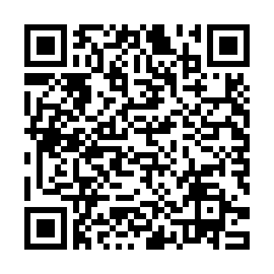

Sincerely,

Traverse Electric Cooperative

For technical help with the survey, please email [surveyhelp@cfigroup.com](mailto:surveyhelp@cfigroup.com)